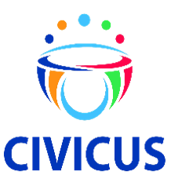
<Event Name> Survey
<Event Date and Location>
Thank you for attending today’s event! Please complete the three-minute survey below. The information will be used by CIVICUS to learn and improve future events. Written comments may be used in reporting and social media.
Your responses are anonymous. Your participation is entirely voluntary, and you may skip any questions that you do not want to answer. We will provide the results and actions we will take based on this survey by sending an email within two weeks.

Thank you in advance!

Best,

[X] CIVICUS Team

1) How likely is it that you would recommend today’s workshop to your friends, family or colleagues?

0 1 2 3 4 5 6 7 8 9 10
Not at all likely Extremely likely
2) What is the most important reason for your score above?

3) Thank you for completing the survey! Is there anything else that you would like for us to know about your experience with CIVICUS? (Please note - If you have an issue that needs specific follow-up, please write to feedback@civicus.org.)

