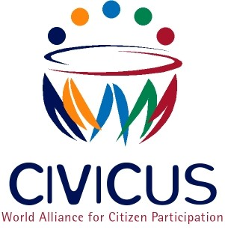

NOMINATIONS FORM – CIVICUS BOARD OF DIRECTORS

Please submit one form per nomination. Nominations are due by midnight GMT, Sunday 28 July 2013. Please place an “X” in the appropriate boxes.

A: Nominees Basic Contact Information

Name of Nominee
Title
Organisation
Address
Telephone/Fax
Email Address

B | Commitment to Serve if Elected
1 | If this is a self-nomination (not requiring a separate letter of intent), do you understand and agree to commit yourself to serving CIVICUS (as specified in item 2 below?)
 |  |  |  |  | Yes |  | No
2 | Has the nominee been contacted about the necessity of submitting a letter
 | of intent by Sunday 28 July 2013? |  |  |  | Yes |  | No
 | The letter should indicate that: he/she accepts the nomination; will become a member of CIVICUS by 1 August 2013 if not presently one; understands the criteria for selection, and is willing to commit at least two weeks of work per year to reviewing and commenting on policy papers, attending Board meetings, serving on at least one committee, representing CIVICUS from time to time, and promoting membership, and is committed to CIVICUS’ mission, vision, values and programmes. (CIVICUS hopes that nominees who are elected will be able to attend the first meeting of the new Board in Johannesburg, South Africa, in the week beginning 11 November 2013).
C | Demographic Information about the Nominee
  Gender |  |  | Male |  | Female
  Age |  |  | Less than 30 |  | 30 – 60 |  | Over 60
  Current Member of CIVICUS |  |  | Yes |  | No

D | Other information about the nominee relevant to the criteria for selection (institutional and individual credibility at national, regional and/or international levels in the civil society movement, experience at managerial levels and/or as a member of boards of directors.

E Please explain why you believe you or your nominee is highly qualified to serve as a director, in terms of CIVICUS’ needs for board members who have national, regional or international credibility within civil society, are experienced managers and/or board members and are committed to CIVICUS’ mission, values and programmes.

F Please insert a brief description of the nominee that will be used for distribution to CIVICUS members. (Maximum 250 words).

Please submit completed nominations forms to the CIVICUS Nominations Committee, via one of the following:

E-mail: nominations@civicus.org

Mail: CIVICUS: World Alliance for Citizen Participation, PO Box 933, Southdale, 2135, Johannesburg, South Africa

Nominations are due by midnight GMT, Sunday 28 July 2013

